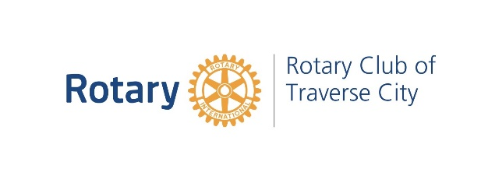
Rotary Club of Traverse City
SUMMARY of FUNDS and FOUNDATIONS

Rotary Foundation: A fund at Rotary International that utilizes your annual donations to support local, district and international projects that change lives by approaching challenges such promoting peace, illiteracy, poverty, malnutrition, clean water, healthcare, and the eradication of Polio with sustainable solutions that leave a lasting impact. Our World Community Service Committee receives approximately $30,000 annually from the Rotary Foundation for projects around the world.

Every Rotarian Every Year (EREY): A program to encourage every Rotarian to donate $100 per year to the Rotary Foundation. That’s only $25 per quarter, or $2 per week. You can donate to the Rotary Foundation by writing a check or having a specific amount billed to you with your quarterly dues.

World Community Service (WCS): A committee within our Club that designates funds, supports projects and creates other sustainable projects to promote education, health and welfare around the world. This committee asks for donations on an annual basis for “seed” money to start and support projects. The donations to WCS are used to leverage matching funds from the District and the Rotary Foundation money. The more money this committee has, more money can be leveraged and accessed from the Rotary Foundation.

GT Regional Community Foundation: An organization that receives gifts to create and build permanent endowment funds. Grants are made by the Community Foundation to IRS exempt organizations to enhance the quality of life in the 5 County Region. The endowments make available for granting, a small percentage of the funds on an annual basis to assure perpetuity.

The Rotary Fund: is a Donor Advised Fund of the Community Foundation. Rotary Charities was and remains the primary donor beginning with an initial gift of $2.5m to create the Fund in 1999 with the goal of encouraging philanthropy by Rotarians. This Fund currently allows every Rotarian in our five-county region access to $250 each year as a matching donation to regional non-profit organizations. It only requires a simple form to be filled out to access these matching funds. Next time you make a donation to a local non-profit organization, fill out the form and the funds will be matched. Matching funds cannot be used for International projects.
- Procedures to access the donation match form
- MATCHING forms on the back table at meetings or ask Kathy
- Go to www.traversecityrotary.org
- Click on MATCHING GIFTS FOR ROTARIANS, on the left
- Click on FORM FOUND HERE, located in the bottom center portion of the page
- Print the form, fill it out and submit it to Kathy Bussell, Club Administrator at
the Rotary Office at 202 E Grandview Pkwy # 200, Traverse City, MI 49684

